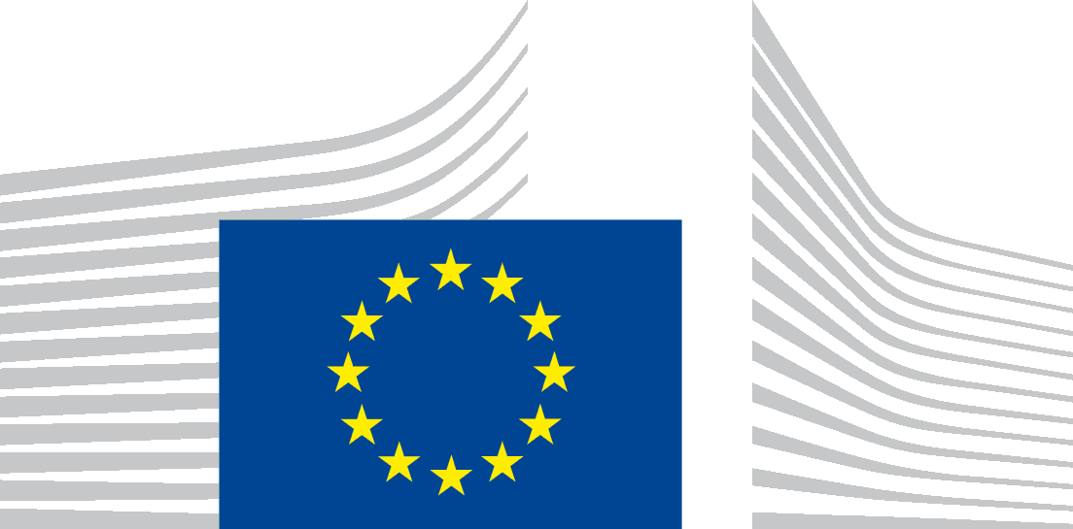 | EUROPEAN COMMISSION  DIRECTORATE-GENERAL  Directorate  Unit

Proposed template for an accessibility statement for Commission-owned websites on the Europa domain

Accessibility statement
This statement applies to content published on the domain: https://eu-diversity-inclusion.campaign.europa.eu/index_en
It does not apply to other content or websites published on any of its subdomains. These websites and their content will have their own specific accessibility statement.
This website is managed by Directorate-General for Justice and Consumers, under the supervision of the Inter-institutional Online Communication Committee (IOCC) . It is designed to be used by as many people as possible, including people with disabilities.
You should be able to:
- zoom up to 200% without problems
- navigate most of the website using just a keyboard
- navigate most of the website using a modern screen reader and speech recognition software (on your computer or phone)]
This website is designed to comply with the technical standard for websites and mobile apps, EN 301 549, v.3.2.1. This closely follows level ‘AA’ of the Web Content Accessibility Guidelines (WCAG) version 2.1.

Compliance status
This website is fully compliant with technical standard EN 301 549 v.3.2.1 and the Web Content Accessibility Guidelines (WCAG) 2.1 Level AA. See ‘Non-accessible content’ for more details.
The website was last tested on 4 July 2025.

Preparation of this statement
This statement was reviewed on 4 July 2025.
A spot-check combined automated scans (axe-core, WAVE, Pa11y) with manual keyboard and NVDA/VoiceOver testing on representative templates.
Because the site is built entirely on certified EWPP components, no WCAG failures were detected.

Feedback
We welcome your feedback on the accessibility of the Promoting diversity in the EU website. Please let us know if you encounter accessibility barriers:
- Phone: 00 800 6 7 8 9 10 11
- Contact form: Write to us
We try to respond to feedback within 15 business days from the date of receipt of the enquiry by the responsible Commission department.

Compatibility with browsers and assistive technology
The Promoting diversity in the EU website is designed to be compatible with the following most used assistive technologies:
- the latest version of Google Chrome and Apple Safari browsers;
- in combination with the latest versions of JAWS, NVDA, VoiceOver and TalkBack.

Technical specifications

The accessibility of the Promoting diversity in the EU website relies on the following technologies to work with the particular combination of web browser and any assistive technologies or plugins installed on your computer:
- HTML
- WAI-ARIA
- CSS
- JavaScript

Non-accessible content
Despite our best efforts to ensure accessibility of the Promoting diversity in the EU website, we are aware of some limitations, which we are working to fix. Below is a description of known limitations and potential solutions. Please contact us if you encounter an issue not listed below.
Known limitations for the Promoting diversity in the EU website:

- some heading elements are not used consistently
- many images do not have alt text descriptions
- many documents are in PDF format and are not accessible

